INTEGRATED PATIO COVER WITH ROTATABLE AND RETRACTABLE ALUMINIUM LOUVRES

Manufacturer
RENSON Outdoor nv, Polydore Rensonstraat 8, 9770 Kruisem – Belgium
Tel. +32(0)56 30 30 00, info@renson.be, www.renson-outdoor.com

(You can omit the text highlighted in red according to your choice)

Description

Aero Skye® is a horizontal patio cover integrated into an existing structure and equipped with a system of aluminium extruded, rotatable and retractable louvres.

Dimensions
Span: Min. 1800 mm
Max. 4500 mm
Pivot: Min. 3250 mm
Max. 6200 mm

Free passage height: Dependent on the supporting structure

For your information:
The span side corresponds to the span of the blades.
The pivot side is the side on which the blades rotate (pivot)

System implementation

Frame:
- Aluminium-extruded profiles, powder-coated in a colour of your choice
- Connections on the same side are finished in a single plane, without protruding cover caps or visible screws
- Height: 260 mm
- Height with louvres in vertical position: 260 mm + 95 mm
- Depth of span-frame profile: 150 mm
- Depth of pivot-frame profile: 330 mm
- Inclination: 0°

Blades:
- Sun protection blades made of extruded aluminium
- Double-walled for handling a heavy snow load
  - 135° rotatable (electronically controlled)
  - Slope: 3 cm over the full louvre length for optimal water drainage
  - Underside completely flat
  - Sides fitted with an L-profile to prevent backflowing water, welded and coated in the same colour as the louvres
  - A triple-folded edge along the louvre length prevents residual water from dripping onto the terrace and furniture when the roof opens
  - Secured on the pivot sides using stainless-steel shafts with integrated locking for a stable construction

Motorisation:
- 4 in-line 24 V DC motors with planetary transmission
- How it works
  - Rotation: Worm and worm gear
  - Retraction/opening: Synchronised spindles with a trolley and chain system
Even and guaranteed parallel sliding
- Placement:
  - The motors are invisibly integrated into the pivot profile

Water drainage:
- Downwards: One or more drainage openings of Ø50 mm are provided in the corner pieces or in the gutter. Each opening has a drainage trap that serves as a leaf catcher and forms the connection to a drain pipe (Ø50 mm) to be connected.
- Sidewards: A sideways-facing drainage pot in the corner pieces for drainage. It has a Ø50 mm to which a drain pipe (Ø50 mm) can be connected.

Assembly:
All fixings (e.g. screws) are invisibly made of stainless steel.
Colour:
All visible aluminum profiles are powder coated in textured paint, RAL color of your choice (60–80 microns).

Power supply and wiring:
Electrical cables are fully integrated, invisibly, into the terrace covering

Technical data:

Maximum weight of snow load:
Meets the static calculations according to DIN-EN regulations (Eurocode)
The load-bearing capacity depends on the dimensions and strength of the supporting structure.
With a maximum span of 4500mm, closed louvres have a load-bearing capacity of at least 520N/m².
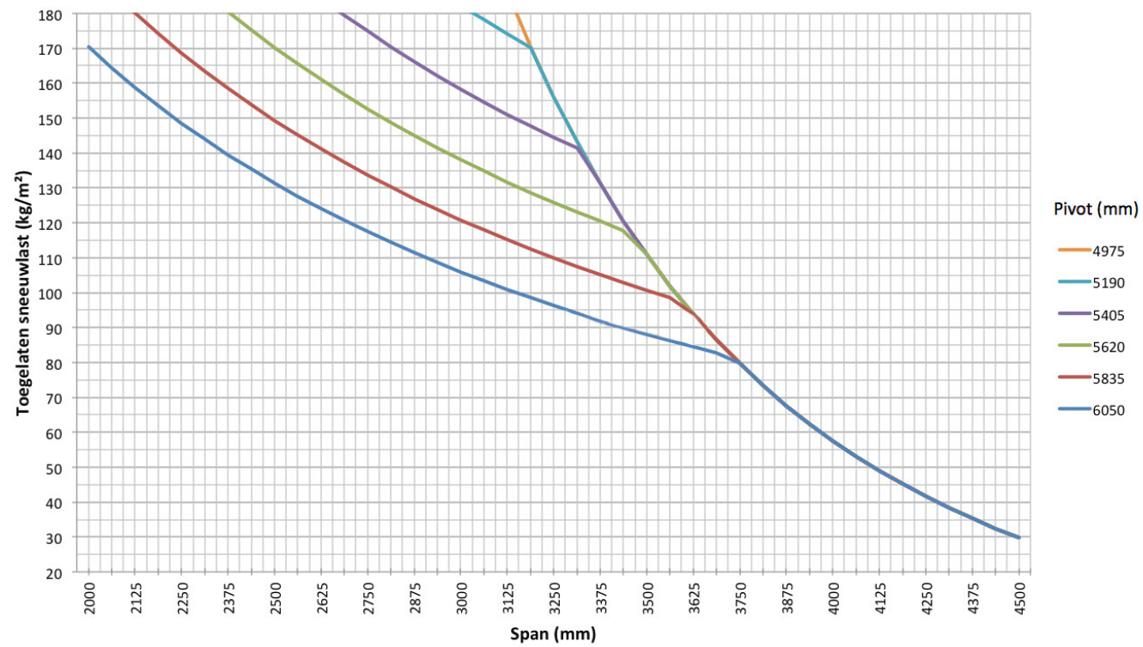

Maximum wind speed when controlling the blades:
120 km per hour (with closed blades)
160 km/h (with stacked blades)

Wind resistant up to:
50 km per hour (with closed blades)

Water drainage and precipitation rate:
The terrace covering can handle precipitation rate that corresponds to a rain shower with an intensity of 150 l/m2.h, which a maximum duration of 2 minutes. This type of rainfall occurs on average every 10 years. (Belgian rainfall statistics: NBN B 52-011)

Warranty
- 10-year product warranty on the structure, subject to registration (all defects that may occur during normal household use and regular maintenance) (standard 5 years)
- 10-year warranty on the paint finish, color, and gloss of the aluminum profiles, subject to registration (standard 5 years)
- 5-year warranty on Somfy and Renson motors.
- 5-year warranty on Somfy controls and sensors.
- 5-year warranty on Lineo Luce, Lineo Fix and Protecto
- 2-year warranty on electrical components (heating, speakers, lighting, etc.)
- 2-year warranty on the rain sensor

Options

Up/Down LED lighting:
Integrated LED lighting along the full length of the inner side of the frame equipped with direct and/or indirect lighting
- Up
  - Warm white light, 120 LEDs/M | +/- 2800 K | 550-680 lumens/m
  - Pure white light, 120 LEDs/M | +/- 5000 K | 550-680 lumens/m
  - RGB 60 LEDs/m | 550-700 lumens/m

- Down
  - Warm white light, 120 LEDs/M | +/- 2800 K | 550-680 lumens/m
  - Pure white light, 120 LEDs/M | +/- 5000 K | 550-680 lumens/m

Beam heat & sound

Beam:
  - The patio cover can be equipped with a Beam module. This is an aluminium housing that can be fitted with heating elements (Heat) and speakers (Sound).
  - Can be mounted on the inside of the frame profiles on the span side.
  - The module can be continuously adjusted with a 30° pivoting range.

Heat:
- Heating element via radiant heat integrated in the Beam module.
- Heating element finished with flat black ceramic glass plate
- Power: 2400 W/Heat, Current = 12A/Heat, IP65
- RTS or IO control (same handheld transmitter as the louvres)

Sound:
- 4 Ohms Marine Speakers IP65 , 2 speakers integrated in the Beam module
- 120W Peak Power , Frequency Response: 90Hz - 22kHz
- Cover plate in black anodised aluminium
- To be connected to an amplifier / radio via the supplied audio cables or with integrated amplifier for autonomous operation and control via smartphone or tablet (incl. bluetooth)
- Dimensions W x H: 180 x 180 mm

Rain sensor kit:
- Rain sensor, fixing materials and accessories
- Closes the blades automatically when there is rain
- It is mounted on a slight incline and has a tiny heating power element for better sensor drying

Wind, snow, frost:
- Adjustable via the app. Weather data is retrieved via the internet.

Norms
This product is made to conform to, satisfies and/or has been tested according to the norm: EN 13561

