INTEGRATED CANOPY WITH FIXED ROOF

Manufacturer
RENSON Outdoor nv, Polydore Rensonstraat 8, 9770 Kruisem – Belgium
Tel. +32(0)56 30 30 00, info@renson.be, www.renson-outdoor.com

(You can omit the text highlighted in red according to your choice)

Description
Aero® Canvas is a horizontal aluminium canopy featuring an upper roof made of profiled steel sheeting and an aesthetic ceiling made of tightly tensioned fiberglass fabric, which is integrated into an existing structure.

Dimensions
Span (longitudinal direction of the louvres): min. 1200 mm – max. 4500 mm
expandable with an intermediate beam up to max. span 6000 mm
Pivot (lateral direction of the louvres): min. 2615 mm – max. 6055 mm

For your information:
The span side corresponds to the width of the steel sheets.
The pivot side is the side along which the different steel sheets are placed next to each other.

System implementation

Frame:
- A sturdy surrounding frame made of extruded aluminium profiles
- Connection of adjacent frame profiles without corner caps
- Each frame profile is equipped with mounting brackets to fix the tensioned ceiling and the upper roof
- Height: 230 mm
- Pitch/Slope: 0°

Upper roof:
- Profiled aluminium steel sheet, equipped on the underside with an anti‑condensation layer to prevent condensation droplets from falling onto the tensioned ceiling below
- The upper roof is fixed to the top frame via the mounting brackets

Ceiling:
- The fixed roof is finished on the underside with a horizontal fiberglass fabric, tensioned tightly using fabric-tensioning profiles
- The fabric is attached all around using zippers, which secure it into a fabric-tensioning profile and to the mounting brackets on the top frame
- The fabric-tensioning profiles can be pulled closer to the frame, thereby tensioning the ceiling fabric and giving it a clean, taut appearance

Water drainage:
- The upper roof (steel sheet) is installed with a 20 mm slope. Water drains through a perforated profile on the side of the upper roof into the gutter, which is integrated into the profiles of the top frame and runs around the entire canopy.
- Downwards: One or more drainage openings of Ø50 mm are provided in the corner pieces or in the gutter. Each opening has a drainage trap that serves as a leaf catcher and forms the connection to a drain pipe (Ø50 mm) to be connected.
- Sidewards: A sideways-facing drain pot runs from the inside of the frame to the outside of the frame. It has a Ø50 mm drain pipe to which a drain pipe (Ø50 mm) can be connected.

Assembly:
All fixings (e.g. screws) are invisibly made of stainless steel.

Colour:
All visible aluminum profiles are powder coated in textured paint, RAL color of your choice (60–80 microns).

Power supply and wiring:
Electrical cables are fully integrated, invisibly, into the terrace covering

Technical data:

Maximum weight of snow load:
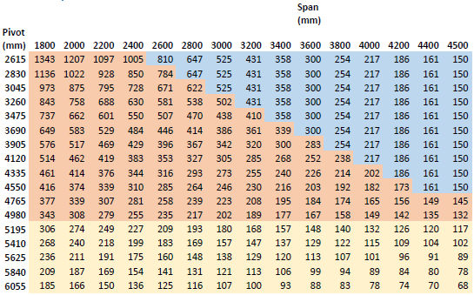

Wind resistant up to:
120 km per hour

Water drainage and precipitation rate:
The terrace covering can handle precipitation rate that corresponds to a rain shower with an intensity of 120 l/m2.h, which a maximum duration of 2 minutes. This type of rainfall occurs on average every 10 years. (Belgian rainfall statistics: NBN B 52-011)

Warranty
- 10-year product warranty on the structure, subject to registration (all defects that may occur during normal household use and regular maintenance) (standard 5 years)
- 10-year warranty on the paint finish, color, and gloss of the aluminum profiles, subject to registration (standard 5 years)
- 5-year warranty on Somfy and Renson motors.
- 5-year warranty on Somfy controls and sensors.
- 5-year warranty on Lineo Luce, Lineo Fix and Protecto
- 2-year warranty on electrical components (heating, speakers, lighting, etc.)
- 2-year warranty on the rain sensor

Options

Up/Down LED lighting:
Integrated LED lighting along the full length of the inner side of the frame equipped with direct and/or indirect lighting
- Up
  - Warm white light, 120 LEDs/M | +/- 2800 K | 550-680 lumens/m
  - Pure white light, 120 LEDs/M | +/- 5000 K | 550-680 lumens/m
  - RGB 60 LEDs/m | 550-700 lumens/m

- Down
  - Warm white light, 120 LEDs/M | +/- 2800 K | 550-680 lumens/m
  - Pure white light, 120 LEDs/M | +/- 5000 K | 550-680 lumens/m

Norms
This product is made to conform to, satisfies and/or has been tested according to the norm: EN 13561

