
SPECIFICATION SHEET (Belgium): AEROO
Version 07/03/2024

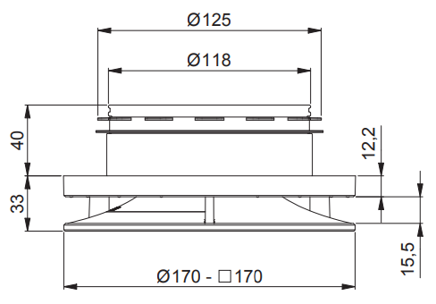
AEROO is an adjustable design valve for both pulsion and extraction. AEROO’s aerodynamically refined design makes it the quietest on the market.

MATERIAL
Material: ASA UPVC
Dimensions:
- Valve connection: Ø125 mm
- Front plate: round Ø170 mm/square 170 x 170 mm
Colour: RAL 9010 (coating can be applied on top)/9005
Mounting: self-clamping rubber

SPECIFICATIONS
∫One valve for both pulsion (up to 90 m³/hr) and extraction (up to 100 m³/hr)
Maximum airflow
- Pulsion side up to 90 m3/h at 21 dB(A)
  - bedroom: up to 75 m³/h at <10 dB(A)
- Extraction side from 100 m³/h at 26.5 dB(A)
Acoustic aspects = Extremely quiet:
- At 90 m³/h pulsion 21 dB (A) in open position without air blocker
- At 100 m³/h extraction 26.5 dB (A) in open position without air blocker
Lowest resistance (in open position) = reduction of central unit energy consumption and noise production
- Pressure drop of 8 Pa in open position and without air blocker at 90 m³/h flow
- Pressure drop of 14 Pa in open position and without air blocker at 100 m³/h flow
Air flow:
- Perfect Coanda pulsion technology ensures comfort and avoids draughts
Endlimit settings:
- Valve with 50 finely tunable endlimit settings while still maintaining whisper-quiet operation throughout a wide operating range
- 2 regulation methods
  - Manual dial with pre-printed letters for better visibility
  - Adjusted key opening for use of setting tool from ground floor
= no ladder necessary
Regulation optimisation (optional)
- Automatic calculation of regulation position per valve possible via algorithm (in combination with high-performance demand-driven D+ ventilation units)

Installation:
- Double function sealing ring
  - Fixing the valve & sealing it airtight
  - no tools or mounting materials required for installation
- Valve assembled and in ‘open position’ in packaging = time saving & installation-ready
- Immediately ready for initial measurement after installation
  - Front plate loose in packaging = time savings & no damage during installation
Cleaning and maintenance:
- Easily removable front plate, without having to remove the connection
  - Valve retains settings during cleaning
  - No damage to ceiling upon removal

REFERENCES
Valves | White (RAL 9010) | Black (RAL 9005)
Aeroo Round | 17147 | 17831
Aero Square | 17148 | 17832
Aeroo Round bulk packaging | 30880 | -

Accessories
Aeroo Air blocker | 12158
Aeroo set-up help | 17149

