TERRACE COVERING WITH ROTATABLE ALUMINIUM BLADES

Manufacturer
RENSON Outdoor nv, Polydore Rensonstraat 8, 9770 Kruisem – Belgium
Tel. + 32 (0)56 30 30 00, info@renson.be, www.renson-outdoor.com

(You can omit the text highlighted in red according to your choice)

Description
Camargue® is an aluminium terrace covering comprising a horizontal sun protection roof, equipped with a rotatable extruded aluminium blade system, which is supported by one, two or four vertical columns, depending on the installation type. The terrace covering can be installed as a free-standing unit or against a façade.

Dimensions
Span: Minimum 1800 mm
Maximum 4500 mm
Pivot: Minimum 1800 mm
Maximum 6200 mm
Free passage height Maximum 2800 mm
Total height, without the motor box: Free passage height + 260 mm
Total height with blades in the vertical position: free passage height + 260 mm + 95 mm
Information:
The "Span side" corresponds to the span of the blades
The "Pivot side" is the side where the blades rotate (or pivot)

System implementation

Frame:
- A sturdy surrounding frame made of extruded aluminium profiles
- Height: 260 mm
- Depth of the Span frame profile: 150 mm
- Depth of the Picot frame profile: 220 mm
- Inclination: 0°

Blades:
- Sun protection blades made of extruded aluminium
- Double-walled for handling a heavy snow load
- Rotatable through 150°
- Underside: completely flat
- Upper side: sharply defined edges + water drainage gutter
- Side edges equipped with hidden fixed L-profile to stop water run-back
- The specific design ensures water drainage when the blades are closed
- And water drains off when you rotate the blades after a shower
- Blade mounting:
  - Fitting into the pivot -sides using the stainless steel shafts
  - A slight inclination on the blades for optimum water drainage

Columns:
- The installation uses 1, 2 or 4 columns, depending on the installation type.
- Dimensions: 150 x 150 mm
- Consists of a central, cross-shaped profile, finished with L-profile s that can be implemented according to custom design, using them as side channels, column lights or as limitation of rapid passage

Mounting bases:
There are 3 types:
- Visible mounting bases with a visible ground plate
- Invisible mounting bases
- Cast mounting bases

Motorisation:
- Electrical: using a 24 VDC linear motor with driving profile.
To connect to the mains voltage (230 Volt AC) through the supplied transformer.
- Placement:
  - The motors are invisibly integrated into the pivot profile

Water drainage:
- Water from the louvers and the invisibly integrated gutters is drained via each column on one Span side.
- Drainage gutters are integrated into the columns on one Span side.
- At the embedded mounting base, the drainage gutter can be connected to a rainwater tank.

Colour:
All visible aluminium profiles are coated in your choice of architectural textured RAL colour (60-80 microns)

Assembly:
All fixings (e.g. screws) are made of stainless steel

Wall Connection:
Optionally, the frame can be equipped with an additional vertical lip. This simplifies the waterproof connection with the structure to which the louvered roof is mounted.

Power supply and wiring:
Electrical cables are integrated fully and invisibly into the terrace covering

Technical data:

Maximum weight of snow load:
See the chart below, according to the dimensions
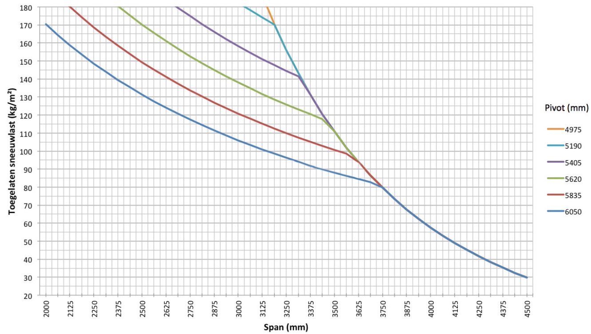

Maximum wind speed when controlling the blades:
50 km per hour

Wind resistant up to:
160 km per hour (with closed blades)

Water drainage and precipitation rate:
The terrace covering can handle precipitation rate that corresponds to a rain shower with an intensity 150 l/m2.h, which a maximum duration of 2 minutes. This type of rainfall occurs on average once every 10 years. (See the Belgian rain statistics: NBN B 52-011)

Warranty
- Guarantee product for 10 years based on the structure (this is due to the defects during the normal use and regular use)
- 10-year warranty on the paint finish, color, and gloss of the aluminum profiles, subject to registration (standard 5 years)
- 5 years warranty on Somfy and Renson motors.
- 5 years warranty on Somfy controls and sensors.
- 2 years warranty on electrical components (heating, speakers, lighting, etc.).
- 2 years warranty on the rain sensor.
- 5 years warranty on the infills (Loggias, glass sliding panels, fixed panels, exterior curtains).
- 5 years warranty on the Fixscreen technology: zip remains in side channel + optimal attachment of the zip.
- 5 years warranty on fibreglass, polyester and acrylic fabrics.

Options

LED blade lighting:
- Blades can be equipped with integrated LED lighting. 180 LEDs/m
  - Warm white light (+/- 2800 K, 1660 lumens/ m)
  - Pure white light (+/- 5000 K, 1660 lumens/ m)
- Specially developed aluminum profiles are used for the lighting in the blades, in which the LED strip is installed along the entire length and finished with a light diffuser for even light distribution (no visible dots) in the same plane as the underside of the blade.
- Connection: 230 Volts AC
- Transformer to 24V DC is included
- This lighting is controlled, as standard, by an independent remote control (on/off and dimming). Control with a Somfy® RTS is possible at extra cost.

LED lighting in columns (no backorder possible):
Integrated LED lighting in the columns:
- Warm white light: 550 – 680 lm/m (120 LEDs/m)
- Pure white light: 550 – 680 lm/m (120 LEDs/m)
UpDown LED - Integrated LED lighting on the inside of the frame.
The Up/Down LED features upward and/or downward lighting providing indirect or direct ambient lighting.
- Up:
  - Warm white light, 120 LEDs/M | +/- 2800 K | 550-680 lumens/m
  - Pure white light, 120 LEDs/M | +/- 5000 K | 550-680 lumens/m
  - RGB 60 LEDs/m | 550-700 lumens/m

- Down:
  - Warm white light, 120 LEDs/M | +/- 2800 K | 550-680 lumens/m
  - Pure white light, 120 LEDs/M | +/- 5000 K | 550-680 lumens/m

Loggia sliding panels:
- Loggia sliding panels comprise 40 x 40, 40 x 55 or 40 x 70 mm powder coated aluminium frames, depending on the passage height. The 40 mm side is always facing towards the front
- This frame is filled in with:
  - Square, aluminium, fixed blades
  - Square, aluminium, rotatable blades
  - Square, Western Cedar, fixed blades
  - Square, Western Cedar, rotatable blades
  - Glass fibre screen fabric
- The sliding panels are suspended in aluminium upper rails and slide in an aluminium bottom rail
- Operation is manual
- The system can handle height differences of up to 5 cm, using a flexible lower guide system
- See the specification text for Loggia sliding panels for a detailed product description

Integrated Fixscreens:
- It is possible to integrate vertical sun protection fabric screens in the terrace coverings with a passage height ≤ 2.8 m
- The frame profiles of the basic structure also form the box for the overhead sun protection
- The side channels are made of extruded aluminium They are 3-piece
- The stepped shape in both components allows you to screw the side channels easily and in the proper manner onto the columns
- See the specification text for Fixscreens for a detailed product description

Glass wall:
- You can build glass sliding panels into terrace coverings with up to 2600 mm passage height, subject to the use of reinforced mounting bases on the adjacent columns
- The glass profiles are made of powder-coated extruded aluminium
- The control is manual
- The glass sliding panels are supported at the bottom by an extruded aluminium rail that is finished with a corrosion resistant guide channel
- The glass is 10 mm thick safety-glass
- You can close the glass wall securely using a lock that you can open and close with a key from either side.

Glass blade
Light-transmitting louver, composed of 8 mm matte laminated safety glass and aluminum support profiles.
- Maximum of 5 glass louvers for a single roof
- Maximum of 3 glass louvers per roof section for a coupled roof

Fixed blade
Fixed non-rotating blade for attaching additional accessories to a bladed roof

Fixed blade with heating:
Heating element with short-wave infrared radiation, aesthetically integrated into a fixed slat in the slatted roof.
- 1 fixed louvre with 1 or 2 heaters
- 2 mounting brackets & accessories
- Shaft and circlip for cable feed-through or sealing stops
- Heating element finished with flat black or white ceramic glass plate
- Power: 1400 W/heat, current = 6.1 A/heat, IP54

Protection profile
- Maintains continuous contact with the blades thanks to a torsion spring
- Durable, silent and smooth movement
- Leave catcher with meshed fabric Powder coated in the same color as the frame and columns
- Back orders possible for covers that have already been installed

Beam Heat & Sound

Beam:
- You can equip the terrace covering with a Beam-
module, an aluminium housing that can house a heating element (Heat) and loudspeakers (Sound).
- Mountable on the inner side of the frame profile on the Span-side
- You can swing the module (stepless) through 30° for adjustment

Heat:
- Radiant heating element integrated into the Beam module.
- Heating element finished with a flat black ceramic glass plate.
- Power: 2400 W/Heat, Current: 12 A/Heat, IP65
- RTS or IO control (same remote control as the louvers)

Sound:
- 4 Ohms Marine Speakers IP65, 2 speakers integrated into the Beam module
- 120W peak power, Frequency response: 90 Hz – 22 kHz
- Cover plate in black anodized aluminium
- Can be connected to an amplifier/radio via the supplied audio cables, or used with an integrated amplifier for autonomous operation and control via smartphone or tablet (incl. Bluetooth)
- Dimensions W x H: 180 x 180 mm

Rain sensor kit:
- Capacity: Rain sensor, mounting materials and accessories
- Action:
  - Closes the blades automatically when there is rain
  - Rotates the blades to their pre-set snow position whenever there is precipitation combined with a freezing temperature
- It is mounted on a slight incline and has a tiny heating element for better sensor drying

Wind sensor kit:
- Capacity: Somfy Eolis RTS or IO Wind sensor and extra accessories
- Action: The blades should be closed when wind speeds are > 50 km/hour, to conform to our warranty terms

Norms
This product is made to conform to, satisfies and/or has been tested according to the norm: EN 13561

