TERRACE COVERING WITH ROTATABLE ALUMINIUM BLADES

Manufacturer
RENSON Outdoor nv, Polydore Rensonstraat 8, 9770 Kruisem – Belgium
Tel. +32(0)56 30 30 00, info@renson.be, www.renson-outdoor.com

(You can omit the text highlighted in red according to your choice)

Description
Algarve® is an aluminium terrace covering, which can be free-standing or mounted onto a façade, and is supported by vertical columns. This terrace covering, which allows adjustable sun protection fabric or ventilation, can be operated electronically.

Dimensions
Span: Minimum 1800 mm
Maximum 4500 mm*
Pivot: Minimum 2610 mm
Maximum 6050 mm without intermediate column
Maximum 7000 mm with intermediate column
Free passage height: Max. 2800
Total height, without the motor box: Fee passage height + 230 mm
Total height including the motor box: Free passage height + 360 mm
*Maximum span 4000 mm if the pivot > 6055 mm

Coupled:
Two roof sections coupled on the pivot side to achieve a longer span side.
No extra column is required between each roof section.
Span per roof section: Minimum 1500 mm
Maximum 4500 mm
Span (the sum of the 2 roof sections) Minimum 3000 mm
Maximum 6000 mm
Information:
The "Span side" corresponds to the span of the blades
The "Pivot side" is the side where the blades rotate (or pivot)

System implementation

Installation type:
- Installation type 1:
  - Free-standing, 4 columns
  - Self-supporting structure
- Installation type 2:
  - Façade mounting
  - Building situation 1:
    - Installed with one side against a backing, supporting construction/structure
    - Blades parallel to the wall
    - Two columns
  - Building situation 2:
    - Installed with one side against a backing, supporting construction/structure
    - Blades perpendicular to the wall
    - Two columns
  - Building situation 3:
    - Installed with two sides (pivot and span-side) against a backing, supporting construction/structure
    - One column

Columns:
- Installation requires 1, 2 or 4 columns, depending on the installation type.
- They are made of square aluminium box profile, 110 mm x 110 mm.

Mounting bases:
There are 2 types:
- Visible mounting bases with a visible ground plate
- Invisible mounting foot

Frame:
- A sturdy surrounding frame made of extruded aluminium profiles
- Connection of adjacent frame profiles without corner caps
- Height: 230 mm
- Inclination: 0°

Blades:
- Sun protection blades made of extruded aluminium
- Rotatable through 150°
- Underside: completely flat
- Upper side: sharply defined edges + water drainage gutter
- Side edges equipped with hidden fixed L-profile to stop water run-back
- The specific design ensures water drainage when the blades are closed
- And water drains off when you rotate the blades after a shower
- Blade mounting:
  - Fitting into the pivot-sides using the stainless steel shafts
  - A slight inclination on the blades for optimum water drainage

Motorisation:
- Linear motor with a driving profile and RTS/IO control
- Placement:
  - The motor is fitted in the frame
  - The motor is concealed in an aluminium housing.
    - 130 mm in height
    - 580 mm long
    - Painted in the same RAL colour as the structure
- Operation can be done via handheld transmitter or app control. With app control, you can easily rotate the louvres to the desired position, as you can see the louvres position visually in the app.

Water drainage:
- Through the column: A Ø 50 mm hole is provided for water drainage in the gutter on the edge of each pivot -side. Each hole has a drainage trap that serves as leaf catcher and a connection for a drainpipe (Ø 50 mm) An opening is provided at the bottom of the column to discharge rainwater. A Ø 50 mm drain pipe connects to the discharge trap to channel the water out of the column.

Assembly:
All fixings (e.g. screws) are made of stainless steel

Wall Connection:
Optionally, the frame can be equipped with an additional vertical lip. This simplifies the waterproof connection with the structure to which the louvered roof is mounted.

Colour:
All visible aluminium profiles are coated in your choice of architectural textured RAL colour (60-80 microns)

Power supply and wiring:
Electrical cables are fully integrated, invisibly, into the terrace covering

Technical data:

Maximum weight of snow load:
Dependent on the dimensions
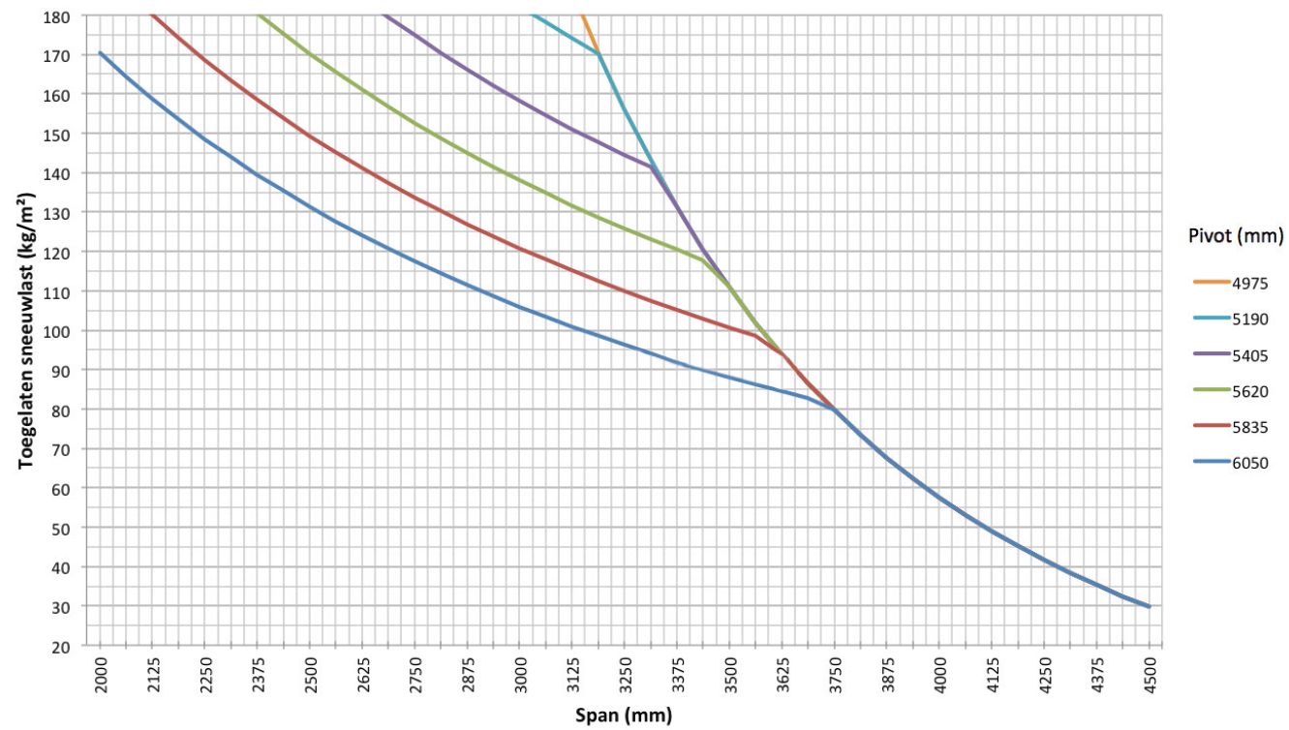

Maximum wind speed when controlling the blades:
50 km per hour

Wind resistant up to:
120 km per hour (with closed blades)

Water drainage and precipitation rate:
The terrace covering can handle precipitation rate that corresponds to a rain shower with an intensity 120 l/m2.h, which a maximum duration of 2 minutes. This type of rainfall occurs on average once every 10 years. (See the Belgian rain statistics: NBN B 52-011)

Warranty
- 10-year product warranty on the structure, subject to registration (all defects that may occur during normal household use and regular maintenance) (standard 5 years)
- 10-year warranty on the paint finish, color, and gloss of the aluminum profiles, subject to registration (standard 5 years)
- 5-year warranty on Somfy and Renson motors
- 5-year warranty on Somfy controls and sensors
- 5-year warranty on Lineo Luce, Lineo Fix and Protecto
- 2-year warranty on electrical components (heating, speakers, lighting, etc.)
- 2-year warranty on the rain sensor
- 5-year warranty on infills (Loggias, glass sliding panels, fixed panels, exterior curtains)
- 5-year warranty on Fixscreen technology (zip stays in side channel + optimal attachment of the zip)
- 5-year warranty on fibreglass, polyester and acrylic fabrics

Options

Algarve Fixscreen
Fixscreen with the screen box and side guides mounted against the supporting structure of the patio cover.
- Also suitable for retrofitting.
- Aluminium, powder‑coated in the colour of the patio cover. All coated profiles in Seaside Quality.
- Dimensions:
- Box size (H × D): 150 × 110 mm
- Fabric tube diameter: 83 mm
- Clear width: 1000 – 6000 mm
Loggia sliding panels:
- Loggia sliding panels comprise 40 x 40, 40 x 55 or 40 x 70 mm powder coated aluminium frames, depending on the passage height. The 40 mm side is always facing towards the front
- Available up to a clear width of 4250 mm
- This frame is filled in with:
  - Square, aluminium, fixed blades
  - Square, aluminium, rotatable blades
  - Square, Western Cedar, fixed blades
  - Square, Western Cedar, rotatable blades
  - Glass fibre screen fabric
- The sliding panels are suspended in aluminium upper rails and slide in an aluminium bottom rail
- Operation is manual
- The system can handle height differences of up to 5 cm, using a flexible lower guide system
- See the specification text for Loggia sliding panels for a detailed product description

Glass wall:
- You can build glass sliding panels into terrace coverings with up to 2600 mm passage height, subject to the use of reinforced mounting bases on the adjacent columns
- The glass profiles are made of powder-coated extruded aluminium
- The control is manual
- The glass sliding panels are supported at the bottom by an extruded aluminium rail that is finished with a corrosion resistant guide channel
- The glass is 10 mm thick safety-glass
- You can close the glass wall securely using a lock that you can open and close with a key from either side.

Beam Heat & Sound

Beam:
- You can equip the terrace covering with a Beam-
module, an aluminium housing that can house a heating element (Heat) and loudspeakers (Sound).
- Mountable on the inner side of the frame profile on the Span-side
- You can swing the module (stepless) through 30° for adjustment bolt

Heat:
- A heating power element that you can integrate in the Beam-module
- The visible, corrugated plate is anodised in black
- Convection heat
- Power: 2600 W/Heat, Power rating = 12 A/Heat
- IP 65
- RTS control (exclusive receiver, remote and controls)

Sound:
- "Flat Panel" type speakers that integrate into the Beam-module
- "Plane Wave" technology
- 25 W RMS, Flat Panel Speaker
- 50 W RMS, Flat Panel Speaker
- IP 65
- Connection: Connects to a tuner/amplifier using an audio cable

LED blade lighting:
- Blades can be equipped with integrated LED lighting. 180 LEDs/m
  - Warm white light (+/- 2800 K, 1660 lumens/ m)
  - Pure white light (+/- 5000 K, 1660 lumens/ m)
- Specially developed aluminum profiles are used for the lighting in the blades, in which the LED strip is installed along the entire length and finished with a light diffuser for even light distribution (no visible dots) in the same plane as the underside of the blade.
- Connection: 230 Volts AC
- Transformer to 24V DC is included
- This lighting is controlled, as standard, by an independent remote control (on/off and dimming). Control with a Somfy® RTS is possible at extra cost.

Up/Down LED:
Integrated LED lighting along the full length of the inner side of the frame equipped with Upwards and/or Downwards lighting
- Up:
  - Warm white light, 120 LEDs/M | +/- 2800 K | 550-680 lumens/m
  - Pure white light, 120 LEDs/M | +/- 5000 K | 550-680 lumens/m
  - RGB 60 LEDs/m | 550-700 lumens/m

- Down:
  - Warm white light, 120 LEDs/M | +/- 2800 K | 550-680 lumens/m
  - Pure white light, 120 LEDs/M | +/- 5000 K | 550-680 lumens/m

Glass blade:
A translucent blade, comprising 8 mm, mat painted safety glass and an aluminium supporting profile
Maximum 5 glass blades on a single roof installation
Max. Three glass blades on a coupled roof installation

Fixed blade:
Fixed non-rotating blade for attaching additional accessories to a bladed roof

Fixed blade with heating:
Heating element with short-wave infrared radiation, aesthetically integrated into a fixed slat in the slatted roof.
- 1 fixed louvre with 1 or 2 heaters
- 2 mounting brackets & accessories
- Shaft and circlip for cable feed-through or sealing stops
- Heating element finished with flat black or white ceramic glass plate
- Power: 1400 W/heat, current = 6.1 A/heat, IP54

Protection profile:
- Maintains continuous contact with the blades thanks to a torsion spring
- Durable, silent and smooth movement
- Leave catcher with meshed fabric Powder coated in the same color as the frame and columns
- Back orders possible for covers that have already been installed

Rain sensor kit:
- Capacity: Rain sensor, fixing materials and accessories
- Action:
  - Closes the blades automatically when there is rain
  - Rotates the blades to their pre-set snow position whenever there is precipitation combined with a freezing temperature
- It is mounted on a slight incline and has a tiny heating power element for better sensor drying

Wind sensor kit:
- Capacity: Somfy Eolis RTS or IO Wind sensor and extra accessories
- Action: The blades should be closed when wind speeds are > 50 km/hour, to conform to our warranty terms

Normen
This product is manufactured according to, complies with and/or has been tested according to the standard: EN 13561

